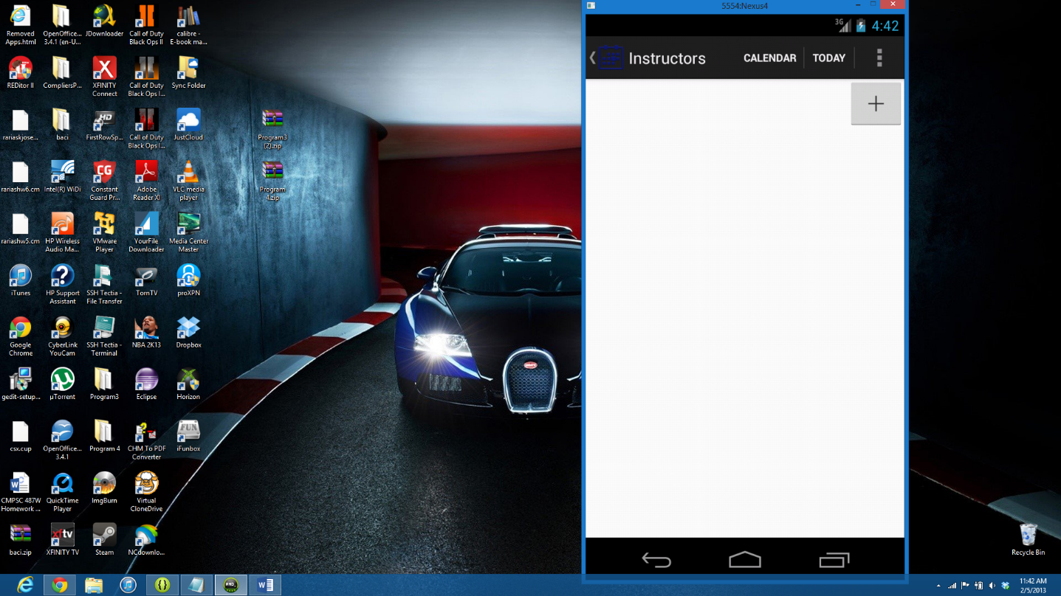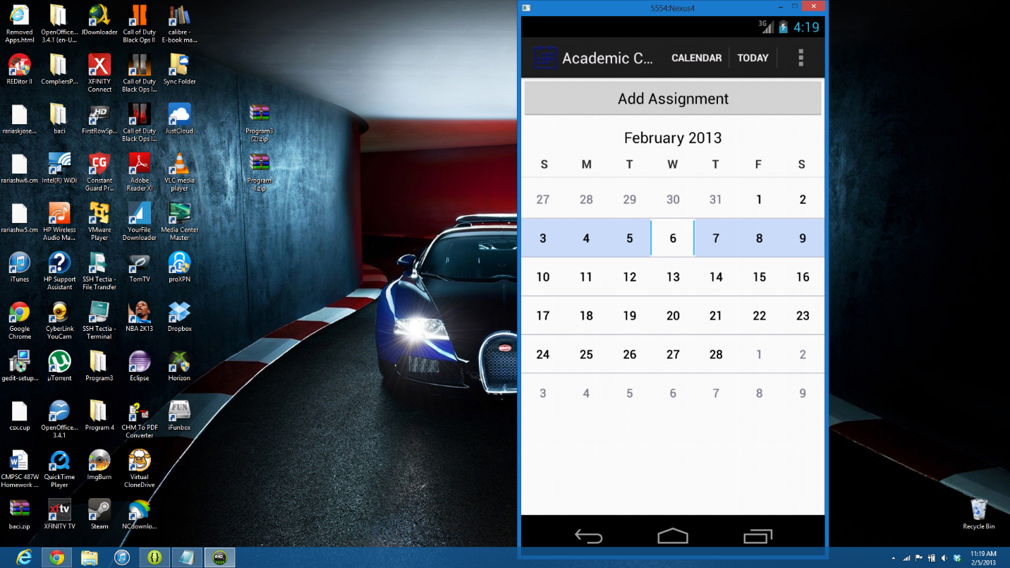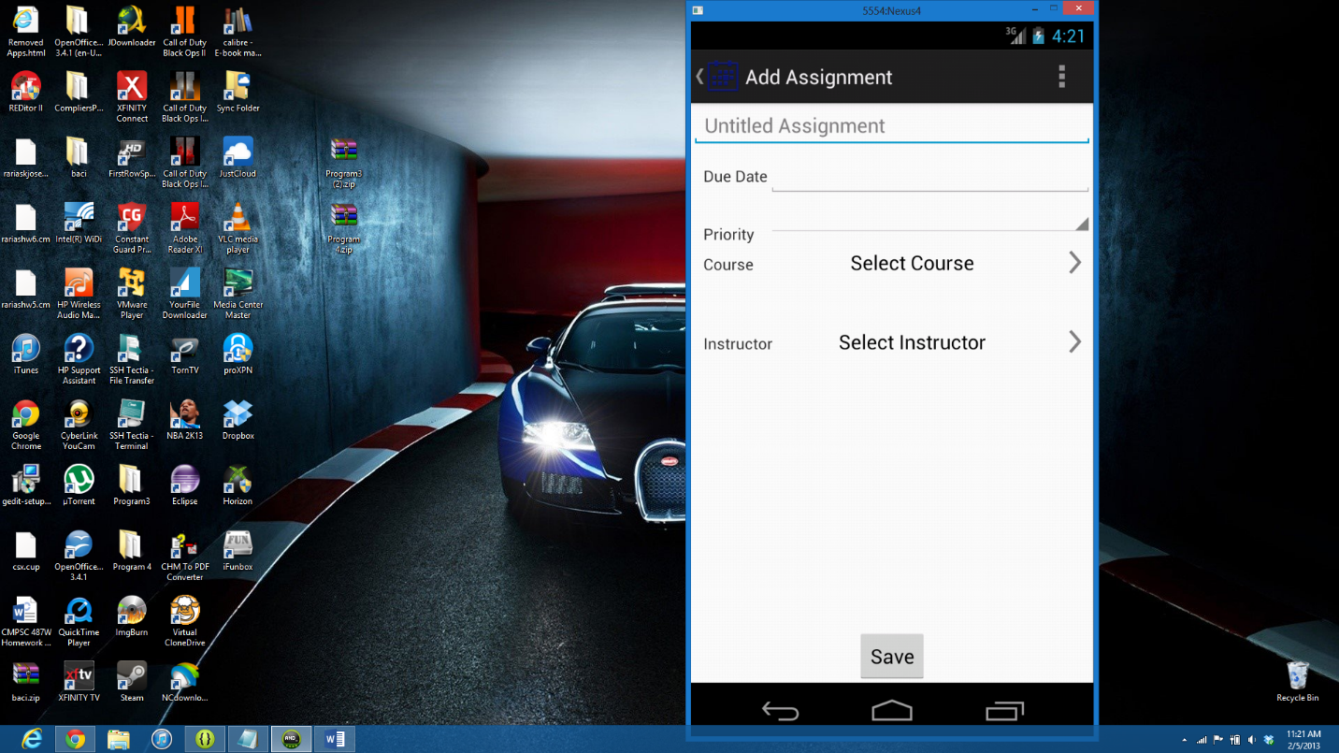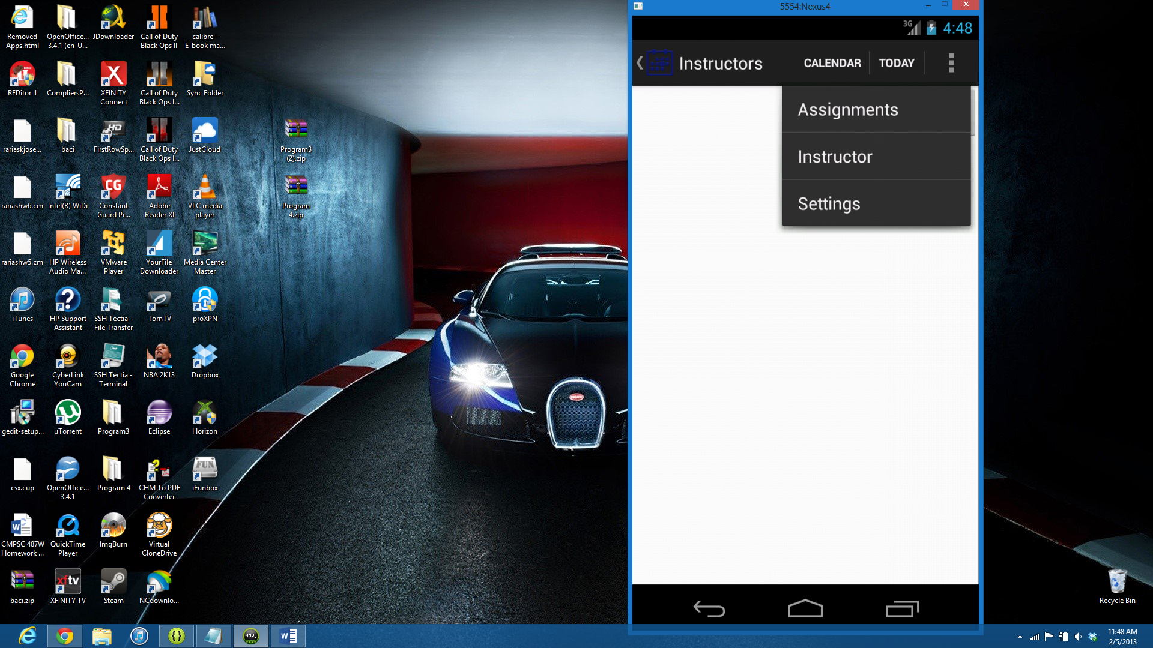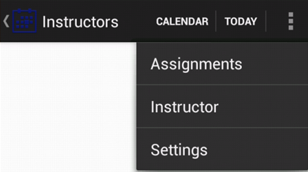

Main Activity (Home Activity). Any activity in action bar’s back button directs you here

Assignment 1

Assignment 2

.

Assignment n

Instructor 1

Instructor 2

.

.

.

Instructor n

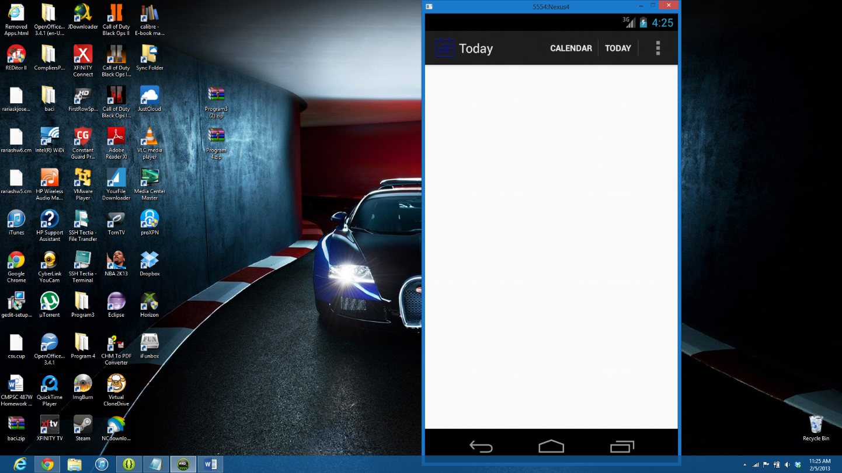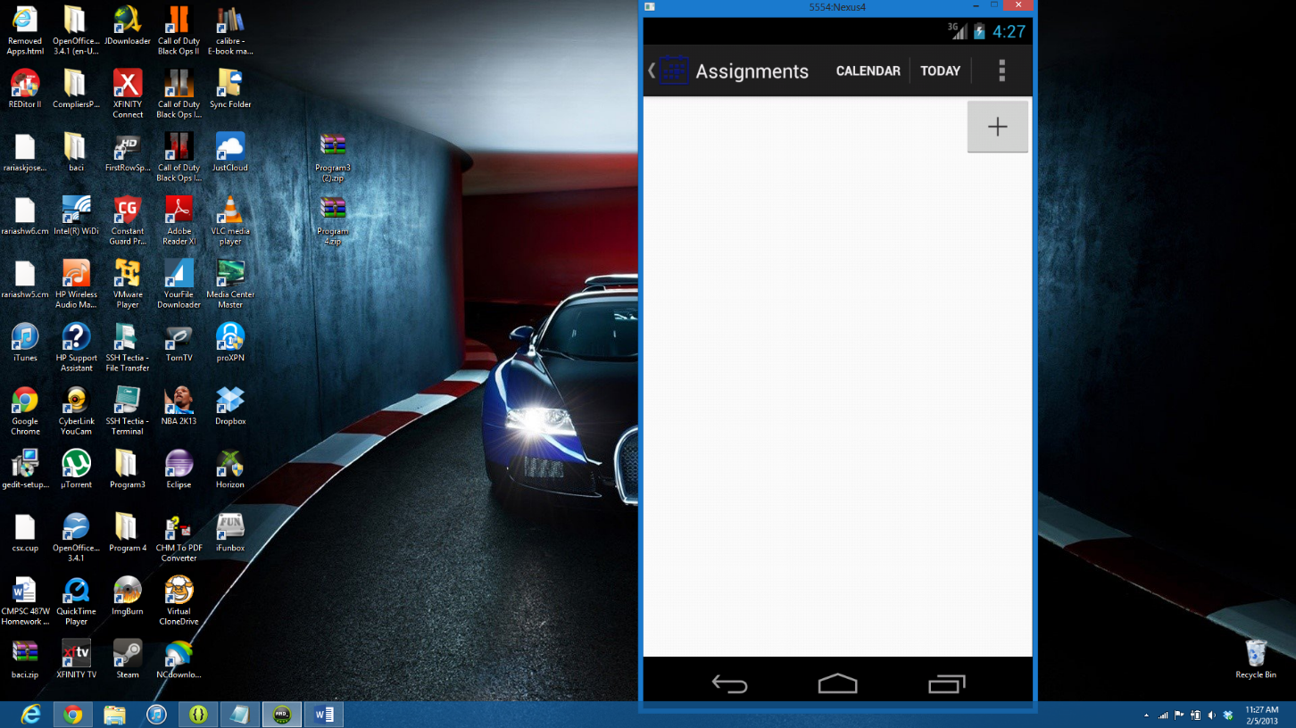

Note: Today activity shows assignments due on the current date.

Assignment 1

Assignment 2

.

Assignment n

Note: Assignment activity shows all assignments due on some date

Instructor 1

Instructor 2

.

.

.

Instructor n

Assignment 1

Assignment 2

.

Assignment n

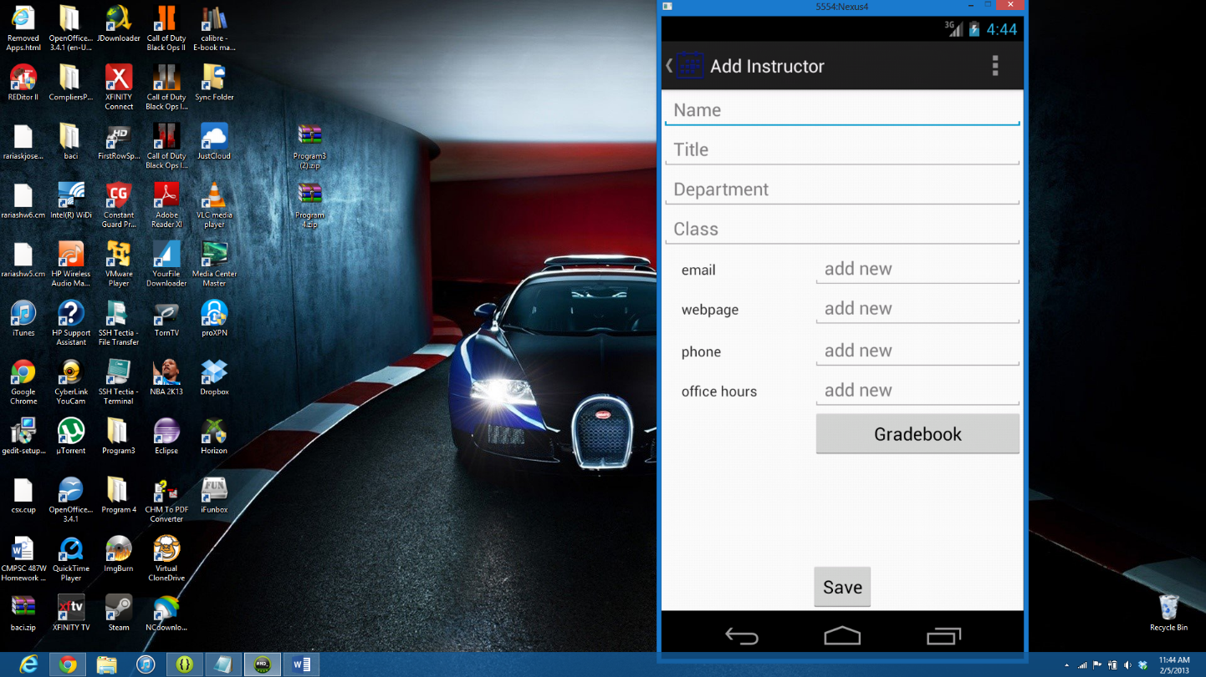

Instructor 1

Instructor 2

.

.

.

Instructor n

